Rwanda

## GNI per capita and development level

The data set shows the GNI per capita and development level of the country each year.

## # A tibble: 19 x 5  
## country iso3c date GNIperCapita devCategory  
## <chr> <chr> <dbl> <dbl> <chr>   
## 1 Rwanda RWA 1996 328. Low Income   
## 2 Rwanda RWA 1998 351. Low Income   
## 3 Rwanda RWA 2000 348. Low Income   
## 4 Rwanda RWA 2002 402. Low Income   
## 5 Rwanda RWA 2003 403. Low Income   
## 6 Rwanda RWA 2004 427. Low Income   
## 7 Rwanda RWA 2005 461. Low Income   
## 8 Rwanda RWA 2006 492. Low Income   
## 9 Rwanda RWA 2007 519. Low Income   
## 10 Rwanda RWA 2008 560. Low Income   
## 11 Rwanda RWA 2009 579. Low Income   
## 12 Rwanda RWA 2010 606. Low Income   
## 13 Rwanda RWA 2011 637. Low Income   
## 14 Rwanda RWA 2012 672. Low Income   
## 15 Rwanda RWA 2013 684. Low Income   
## 16 Rwanda RWA 2014 705. Low Income   
## 17 Rwanda RWA 2015 747. Low Income   
## 18 Rwanda RWA 2016 770. Low Income   
## 19 Rwanda RWA 2017 782. Low Income

## GDP growth and economic growth classification

The data set shows the GDP growth and the ecomic growth classification of the country each year.

## # A tibble: 19 x 5  
## country iso3c date GDPannualGrowthRate GDPgrowthCategory4  
## <chr> <chr> <dbl> <dbl> <fct>   
## 1 Rwanda RWA 1996 12.7 fast growth   
## 2 Rwanda RWA 1998 8.86 fast growth   
## 3 Rwanda RWA 2000 8.37 fast growth   
## 4 Rwanda RWA 2002 13.2 fast growth   
## 5 Rwanda RWA 2003 2.20 slow growth   
## 6 Rwanda RWA 2004 7.45 fast growth   
## 7 Rwanda RWA 2005 9.38 fast growth   
## 8 Rwanda RWA 2006 9.23 fast growth   
## 9 Rwanda RWA 2007 7.63 fast growth   
## 10 Rwanda RWA 2008 11.2 fast growth   
## 11 Rwanda RWA 2009 6.25 fast growth   
## 12 Rwanda RWA 2010 7.33 fast growth   
## 13 Rwanda RWA 2011 7.96 fast growth   
## 14 Rwanda RWA 2012 8.64 fast growth   
## 15 Rwanda RWA 2013 4.72 moderate growth   
## 16 Rwanda RWA 2014 6.17 fast growth   
## 17 Rwanda RWA 2015 8.86 fast growth   
## 18 Rwanda RWA 2016 5.97 fast growth   
## 19 Rwanda RWA 2017 3.98 moderate growth

## Development trend

The plot shows the development trend of the country.

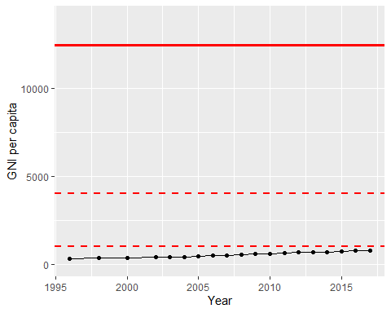

GNI Per Capita Trend